**Artificial Intelligence Methods for Medical Imaging Analysis - Autodetection of Median Nerve in Ultrasound of the Wrist**

**INTRODUCTION:**

Ultrasound is an important diagnostic imaging tool, commonly used in healthcare for the evaluation of internal body structures. Computer-aided diagnosis (CAD) has become a significant research subject in medical imaging and diagnostic radiology. CAD is widely applied in the detection and differential diagnosis of various abnormalities in medical images obtained through different imaging modalities [1].

Computer-aided diagnostics involve two key elements: detection and diagnosis. Detection is the technology used to locate the organ, while diagnosis means identifying the disease [2].

This project aims to detect the median nerve in ultrasound images of the wrist.

**REVIEW OF LITERATURE:**

**Peripheral Nerves and Neuropathy:**

Peripheral nerves are components of the peripheral nervous system, which includes all nerves outside the brain and spinal cord. They are composed of bundles of axons, nerve fibers responsible for transmitting signals between the central nervous system and the body [3]. Nerves are classified into sensory, motor, and autonomic types. They have a protective covering called the myelin sheath, which aids in efficient signal transmission [4].

Important upper limb nerves include the median, ulnar, and radial nerves. Lower limb nerves include the femoral, sciatic, common peroneal, and tibial nerves [5].

Neuropathy refers to disorders that result from damage to peripheral nerves. Common causes include diabetes mellitus, physical injuries, infections like Lyme disease, autoimmune disorders, nutritional deficiencies, and exposure to toxins [6].

Symptoms of neuropathy include motor weakness, altered sensation of limbs, burning pains, cramps, etc.

**Evaluating Peripheral Neuropathy:**

Clinical assessment of peripheral neuropathy involves detailed medical history, sensory and motor function tests, nerve conduction studies (NCS), and electromyography (EMG) [7].

**Ultrasound of the Peripheral Nerve:**

Ultrasound imaging of peripheral nerves is valuable for assessing nerve entrapments, structural abnormalities, and traumatic injuries. High-resolution ultrasound provides detailed visualization of nerve size, echotexture, and presence of neuromas or nerve sheath tumors. It complements electrodiagnostic studies by providing anatomical insights and guiding interventions such as nerve blocks or surgery [8].

**Median Nerve:**

The median nerve originates from the brachial plexus and travels through the arm and forearm. It passes through the carpal tunnel, where it innervates the thenar muscles and provides sensory function to the thumb, index, and middle fingers. Carpal tunnel syndrome occurs when the median nerve is compressed within this narrow passage, leading to symptoms such as numbness and pain [9].

Ultrasound is a non-invasive technique used to evaluate carpal tunnel syndrome. It allows visualization of the median nerve, measurement of nerve size, and detection of nerve compression [10].

Doctors get trained in performing nerve ultrasound. Identifying peripheral nerves through ultrasound has a long learning curve. While performing ultrasound guided nerve blocks, it is very crucial to accurately identify the nerve to prevent complications. The current study aims at using technologies of deep learning in autodetection of the nerves in a given ultrasound image. By developing deep learning models, we aim to aid doctors in identifying the nerve.

**AI and Machine Learning:**

Artificial Intelligence (AI) and Machine Learning (ML) enable computers to learn from data and make decisions. Key ML approaches include supervised learning (trained on labeled data) and unsupervised learning (finding patterns in unlabeled data) [11].

**Deep Learning:**

Deep learning, a subset of ML, uses neural networks with multiple layers to model complex patterns in data. It has revolutionized image recognition, speech recognition, and natural language processing by automatically extracting features from large datasets [12].

**Convolutional Neural Networks (CNNs):**

CNNs are deep learning models designed for processing structured grid data like images. They consist of layers that perform convolutions, pooling, and activation functions, enabling efficient detection of patterns such as edges and shapes. CNNs are widely used for image classification, object detection, and facial recognition [13].

**U-Net Architecture:**

U-Net is a convolutional neural network (CNN) architecture specifically designed for image segmentation, particularly in biomedical applications. It consists of an encoder (contracting path) and a decoder (expanding path), using skip connections to preserve spatial information [14]. U-Net is effective even with small datasets, making it ideal for tasks like tumor and organ segmentation in medical imaging [15].

**METHODOLOGY:**

**Data Source:**

The dataset was provided by the Medical Imaging Group (MIG) at the Indian Institute of Science, Bangalore, where I was offered an internship.

**Data Labeling:**

The labeling process involved manually segmenting the median nerve in 110 images using ImageJ. The images were converted to grayscale, and the median nerve was outlined using the Elliptical Brush Tool. Filters were applied to reduce noise, and each segmented image was saved as a binary file: each pixel is represented by one of two values, that is belonging to the nerve or not belonging to the nerve, respectively as 0 or 1. [16].

**Model Preparation:**

To segment the median nerve, a U-Net model was employed due to its ability to accurately capture fine details in biomedical images [17].

**Loss Function and Optimizer:**

Binary Cross-Entropy with Logits Loss (BCEWithLogitsLoss) was used as the loss function, and the Adam optimizer was selected for its efficiency in adaptive learning [18].

**Model Evaluation:**

**Metrics:**

Precision, recall, and Dice score are key metrics used to evaluate the performance of models in classification tasks, particularly in contexts like image segmentation. Precision measures the proportion of true positive predictions to the total predicted positives, indicating how many of the predicted positive cases were correct.

Recall, also known as sensitivity, measures the proportion of true positives to the total actual positives, reflecting the model's ability to identify all relevant instances.

The Dice score, or F1 score, combines precision and recall into a single metric, calculated as the harmonic mean of the two, and ranges from 0 to 1, where 1 indicates perfect agreement between the predicted and actual positive cases.

The u-net model was implemented by using Pytorch. The metrics that was obtained on our dataset were as follows:

Precision: 0.9471

Recall: 0.946

Dice score: 0.946

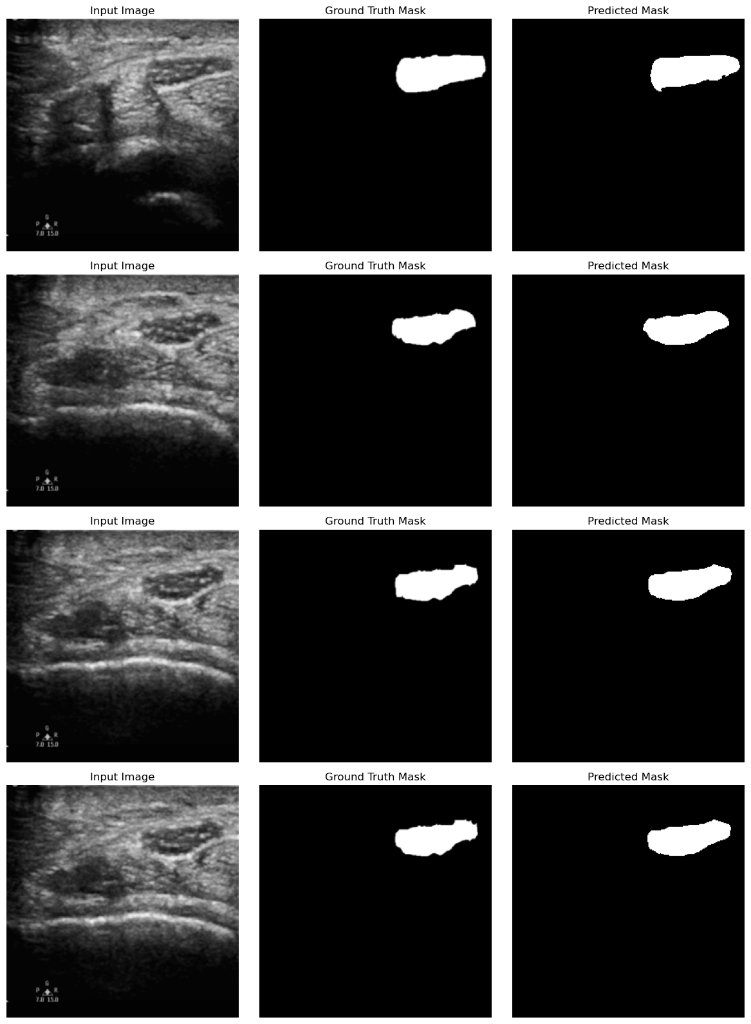

**References:**

1. S. Giger, "Computer-aided diagnosis in medical imaging: Historical overview, current status and future potential," Computerized Medical Imaging and Graphics, 2000.
2. P. Yadav et al., "Computer-aided diagnostic tools in medical imaging," Journal of Medical Imaging, 2018.
3. J. R. Boulton et al., "Anatomy of the peripheral nervous system," Journal of Neurology, 2016.
4. G. Kandel et al., *Principles of Neural Science*, McGraw-Hill, 2013.
5. D. Johnson, "The anatomy and function of upper and lower limb nerves," The Lancet Neurology, 2015.
6. M. Callaghan et al., "Diabetic neuropathy and other causes of peripheral neuropathy," The Lancet, 2012.
7. A. Cornblath, "Clinical evaluation and diagnosis of peripheral neuropathy," Journal of Clinical Neurology, 2015.
8. E. Dumitru et al., *Peripheral Nerve Injuries: Principles of Diagnosis*, Elsevier, 2012.
9. A. Andermann, "The clinical features of carpal tunnel syndrome," *The New England Journal of Medicine*, 1997.
10. M. Cartwright et al., "Ultrasound evaluation of carpal tunnel syndrome," *Journal of Clinical Ultrasound*, 2007.
11. L. Deng, "Machine Learning Foundations," *Foundations and Trends in Signal Processing*, 2012.
12. Y. LeCun, Y. Bengio, and G. Hinton, "Deep Learning," *Nature*, 2015.
13. A. Krizhevsky et al., "ImageNet Classification with Deep Convolutional Neural Networks," *Advances in Neural Information Processing Systems*, 2012.
14. O. Ronneberger et al., "U-Net: Convolutional Networks for Biomedical Image Segmentation," *MICCAI*, 2015.
15. K. Simonyan et al., "Very Deep Convolutional Networks for Large-Scale Image Recognition," *ICLR*, 2015.
16. W. Rasband, *ImageJ User Guide*, NIH, 2018.
17. O. Ronneberger et al., "U-Net for Image Segmentation," *MICCAI*, 2015.
18. D. Kingma et al., "Adam: A Method for Stochastic Optimization," *ICLR*, 2015.